Task 1: User Story Mapping

Defining vision:

* Mission: to build a student buddy system for INTI International College Penang (IICP) as there is not much system that not only aid international students in efficiently by finding a buddy from local place, but it also helps those local students who want to make some friends.
* Users: international students, local students, buddy i.e., the persons who volunteer to make friends with them, admins i.e., the representative of the student buddy system who is responsible for matching local buddy with an international student and friendly buddy with a student.
* Value and benefits of this product:
  + improve the integration of international students and they also can benefit from their interactive welcomes thanks to their local buddies.
  + experience intercultural exchanges and open-minded for local students.
  + enhance student’s mobility facilities and enabling admin to form long-term alliances by providing them with common communication, facilitation, and training tools.
  + give chances around the college for those loneliness students who want to make some new friends.
  + make bonds with people in college and promote interacting and conversation between each other.

Interview results:

Link: <https://docs.google.com/forms/d/1sW9E-mGd879Yqgm90msGoDGHwJEkXtQ5x5VGB94KrnA/edit#responses>

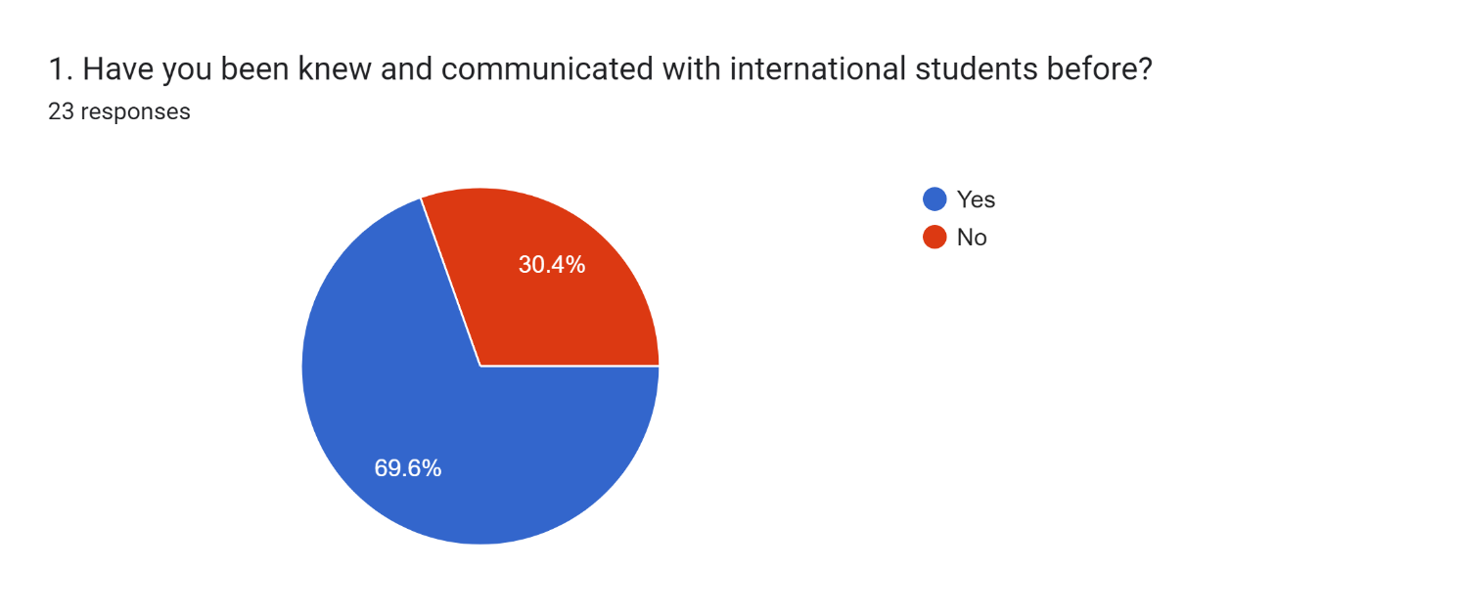

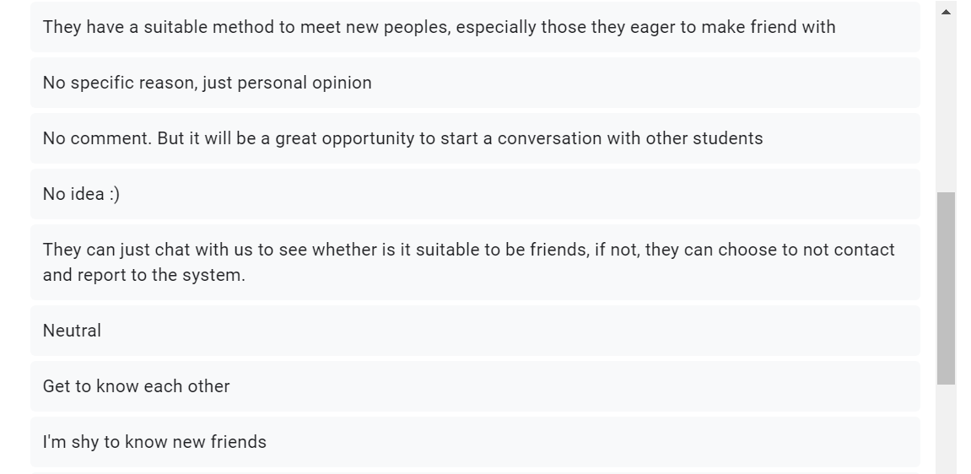

User Story Mapping:

Link: <https://miro.com/app/board/uXjVPV-ryOM=/>

Note: Sub-task

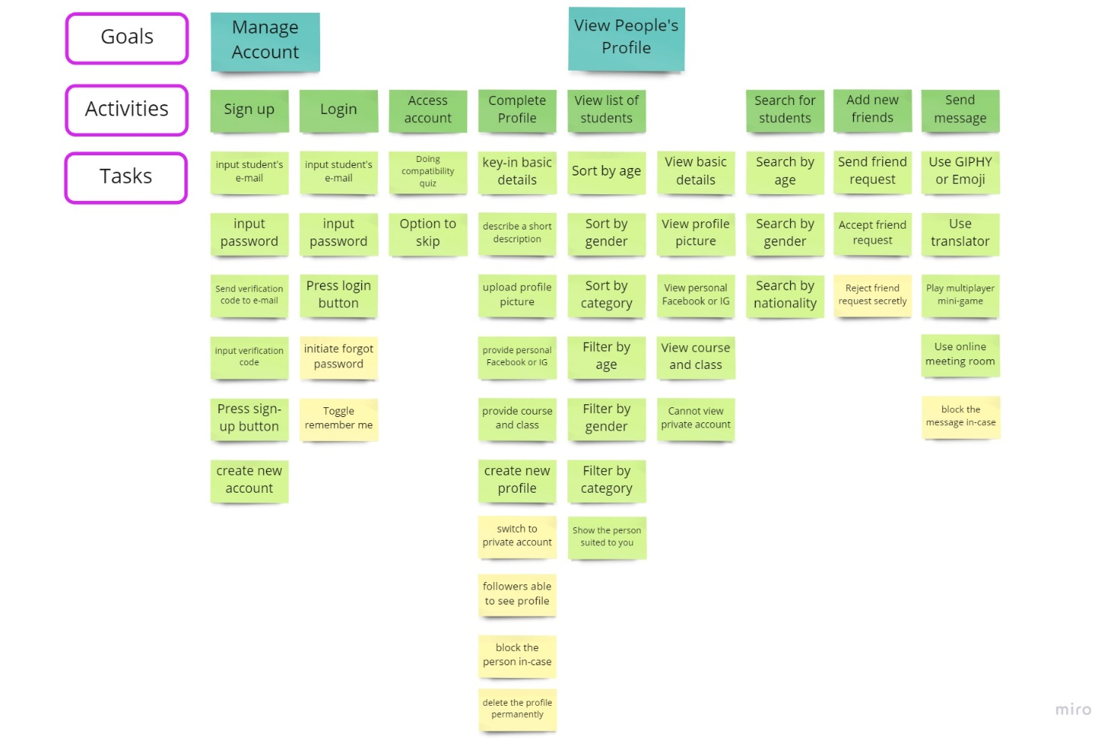

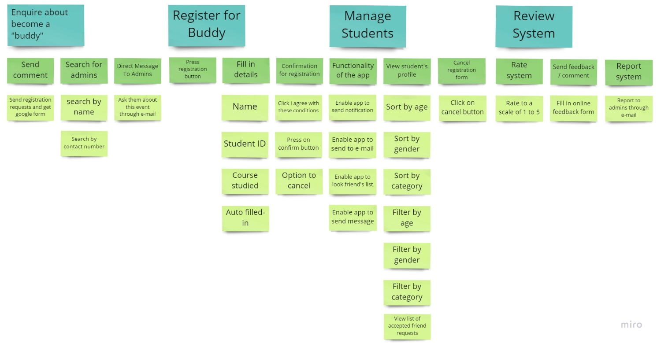

Further explanation of the whole user story mapping for international or local students / users:

Sign-up account:

Before creating new account, users need to input their e-mail, password, and verification code. Next, they need to do compatibility quiz to match the friends that suited to them.

Main menu slide:

In the homepage, which is the personal profile, the users can slide open a side main menu to access their own profile and still can edit if they want to change or upload the profile.

View people’s profile:

Users can see others’ profile and search them by sorting age, gender, and nationality to find their compatible friends, but they can view those switches on private account. After they send friend request and get accept, they can start to message by using GIPHY or play some mini- game to break the ice.

Further explanation of the whole user story mapping for buddy:

Sign-up account:

Before creating new account, buddy need to input their e-mail, password, and verification code.

Main menu slide:

In the homepage, which is the personal profile, they can slice open a side main menu to access the volunteer /buddy - oriented features.

View people’s profile:

Users can see others’ profile and search them by sorting age, gender, and nationality to find their compatible friends, but they can view those switches on private account. After they send friend request and get accept, they can start to message by using GIPHY or play some mini- game to break the ice.

Built-in fill up forms:

Buddy can straight away do registration requests without needing to find the admin to obtain google forms.

Further explanation of the whole user story mapping for admins:

Maintenance to the Build-System:

Admins need to ensure that the function ability of the apps is perfect and enhance the apps after the feedback or comment given. Besides, they can cancel registration for those volunteers who cannot become buddy in sudden.